Build a base

Business vision

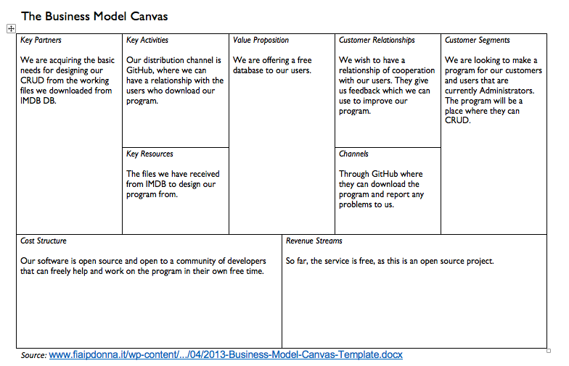

Usecases

UC 1 - Read (Fully dressed)

**Name:** Build a base

**Scope:** The program

**Primary actor:** User

Secondary actor: Administrator

* The person who add new people/movies.

**Stakeholder and interests:**

* KEA administration.

**Pre-conditions:**

User being able to open/use/close program,

TheCRUD operations (Create, Read, Update, Delete)

**Succes Guarantee:**

**Main success scenario:**

1. The program takes user input requesting information on a specific person.
2. The program searches through the database, and locates the person based off the input.
3. The program offers a list of people, except those which are marked deleted, with matching data and highlights the ID.
4. The user exits the program via the menu.

**Extensions:**

1. The program crashes due to hardware and/or software failure.
2. The search has no matches.

**Special Requirements:**

1. The program can manage large quantities of data.
2. The program needs to be accessible without internet.(?)
3. The program should have “easy to use” search functionality:

You don't need to be an expert to find people/movies etc.

UC 2 - Create (Brief)

Main success scenario:

The user starts the program and requests to add a new Movie. The Movie is added at the bottom, so no other data needs to be rearranged to make space for it, and no indexes, if created, need updating.

UC 3 - Update (Brief)

Main success scenario

The user starts the program and requests to update the number of episodes in a season, the program performs the necessary updates. The program prevents users from updating IDs. Deleted entries cannot be updated unless explicitly undeleted.

UC 4 - Delete (Brief)

Main success scenario:

The user starts the program and requests to delete/deactivate/remove existing entries. Deleted entries remain in the database but are marked deleted.

Use Case Diagram

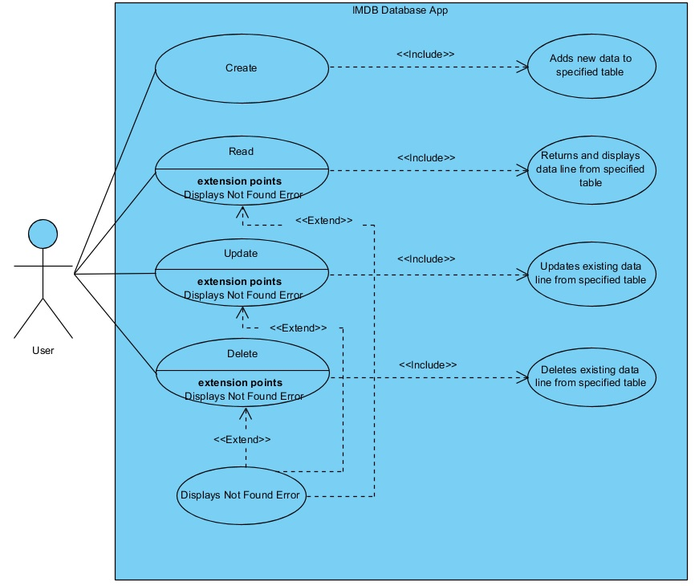

Domain model

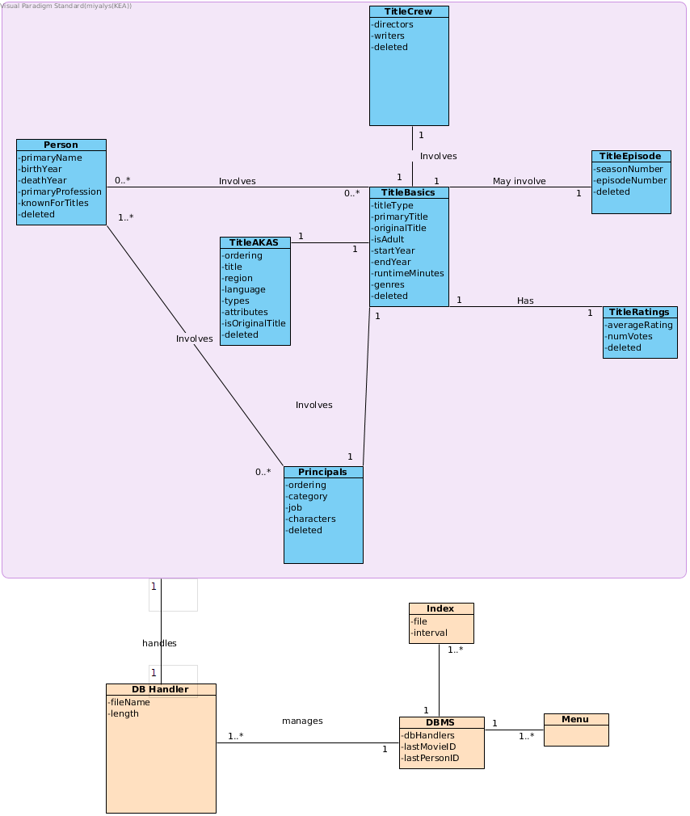

System Sequence Diagram

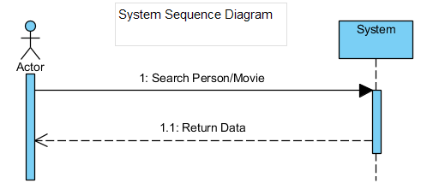

Sequence Diagram

UPDATE: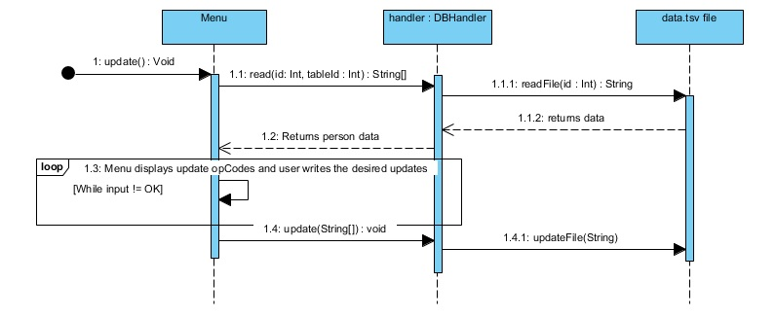

Class Diagram

